**Screenshots for Network Topology 1**

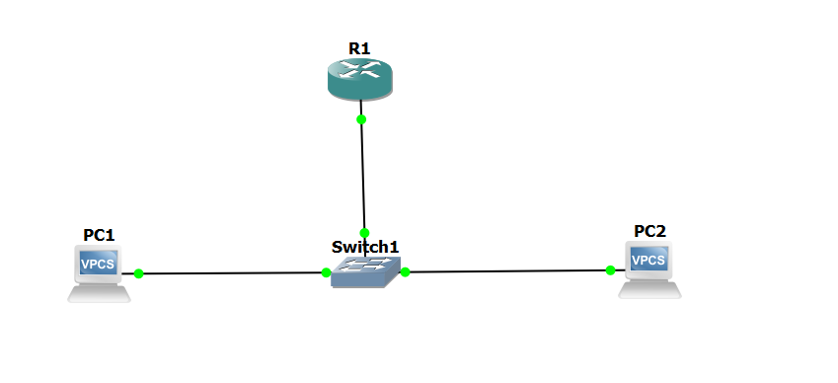

**Screenshots for Router Configuration (Console Screenshots)**

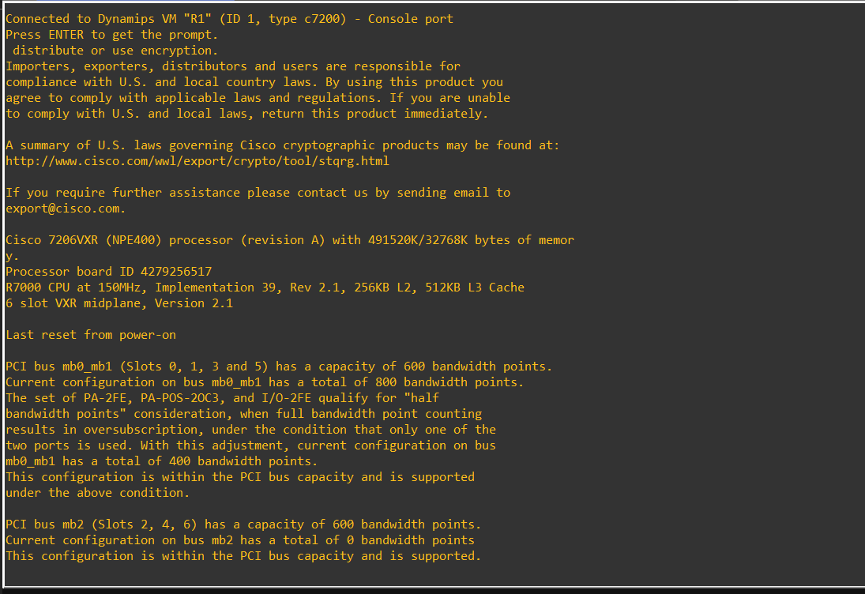

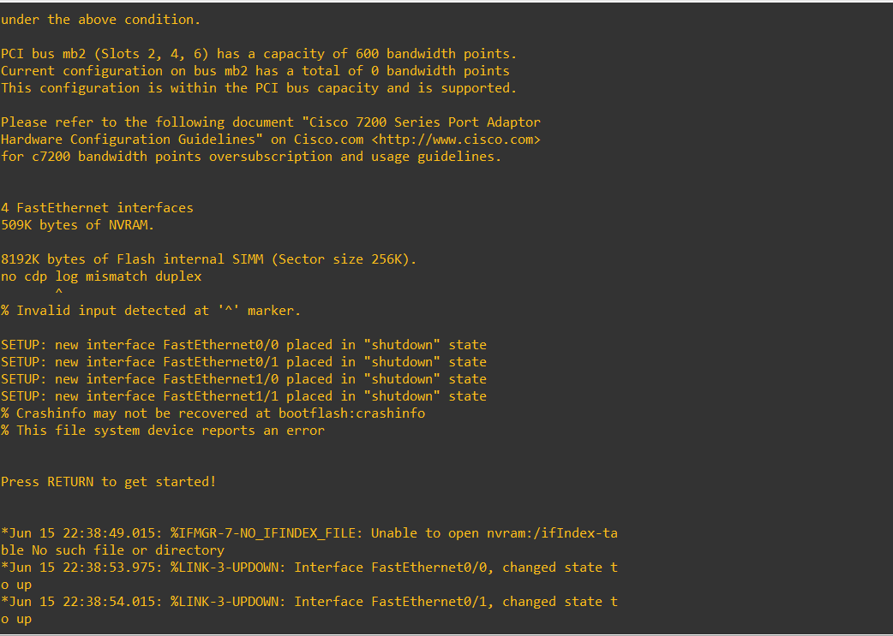

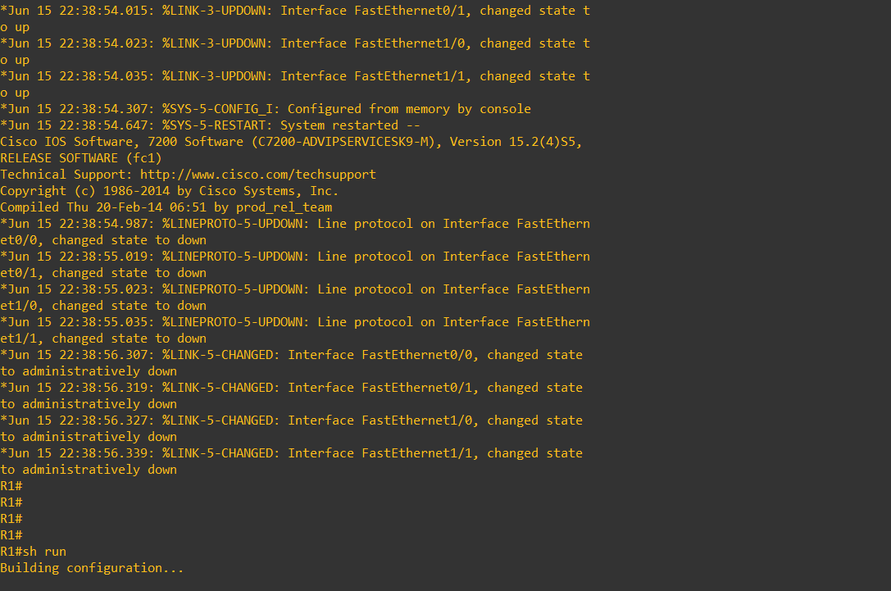

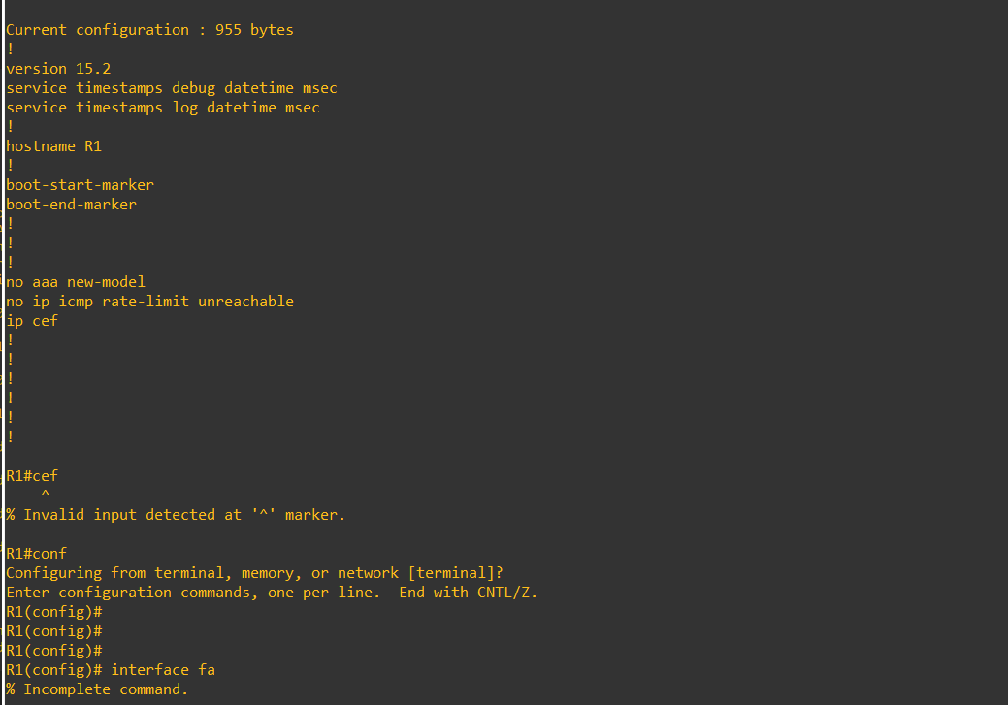

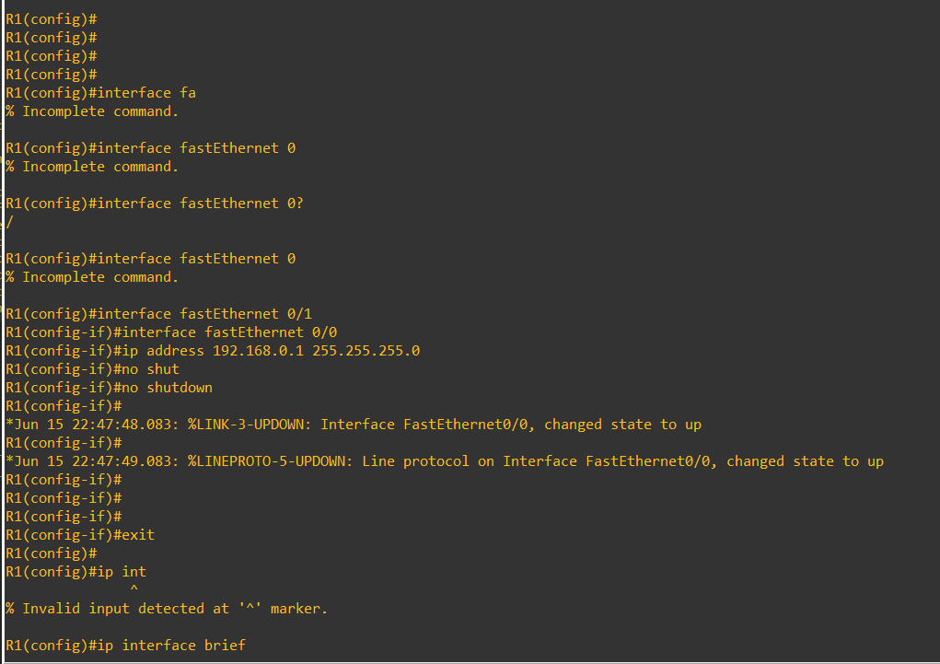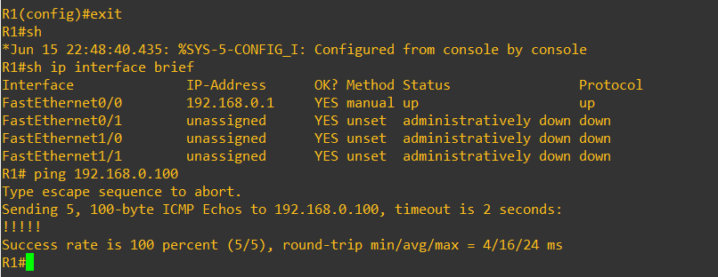

**Screenshots for PC1 Configuration (Console)**

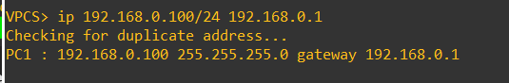

**Screenshots for PC2 Configuration (Console)**

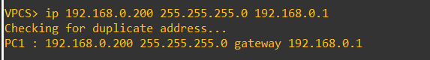

**Ping Host 2 From Host 1  
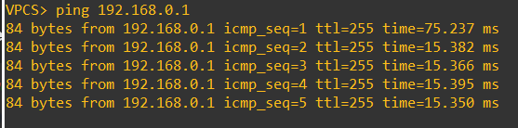**

**Ping Host 1 from Host 2**

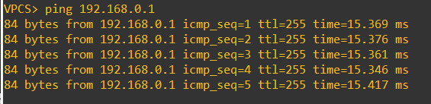

**Ping Both PCs through Router**

